Name: LABMATE AI
githubUrl: https://github.com/Balaji-0117/LabMate.git
Description:
A smart digital companion for engineering students featuring controllable simulations of real lab experiments, accessible anytime.
Students can interact with the simulations, adjust values, and observe results — just like a real lab environment on screen.
The AI doubt solver, auto-generated observation tables, and PDF record generation make lab work faster and cleaner.
Professors get their own panel to manage exams, evaluate students, and track class performance.
Everything — simulations, records, doubts, and exams — all in one platform, accessible from anywhere.

Functional Requirements

Implemented Features

Authentication System

User registration and login

JWT-based authentication

Secure password handling

Role-based access structure(In Progress)

Student Dashboard

Display experiment modules and dashboard sections

Track experiment workflow status

Responsive dashboard interface

Recent activity and progress overview(In Progress)

Virtual Lab Simulations

Interactive experiment simulation interfaces

Real-time parameter adjustment controls

Simulation workflow visualization

Experiment reset functionality

Browser-accessible virtual lab environment

Observation & Workflow Management

Observation table interfaces

Dynamic value handling from simulation inputs

Experiment workflow tracking

Editable experiment-related data fields

Review & Analytics Interface

Dashboard analytics visualization

Experiment progress indicators

Performance overview UI (In Progress)

Frontend Architecture

Responsive UI design

Modular component structure

Dark/light mode support

User-friendly navigation system

Features Under Development

AI Assistance

AI-powered viva question generation

AI chatbot for experiment guidance

Concept explanation assistance

Context-aware doubt resolution

Report & Documentation System

Automated PDF report generation

Experiment record export functionality

AI-generated experiment summaries

Professor Dashboard

Experiment management panel

Student submission monitoring

Evaluation and marking workflows

Faculty feedback system

Database & Backend Expansion

PostgreSQL schema integration

Experiment submission APIs

Record persistence and management

Advanced backend validation systems

Advanced Analytics

Student performance analysis

AI-assisted weak-area identification

Experiment completion analytics

Comparative progress reports

Non-Functional Requirements
Problem_Statement: Engineering students often struggle with managing laboratory experiments, observation records, simulations, viva preparation, and report workflows across multiple disconnected platforms and manual processes. Faculty members also face difficulties in monitoring student progress, evaluating submissions, and maintaining efficient academic lab management.
Many existing laboratory systems lack interactive learning support, centralized experiment management, simulation-based practice environments, and modern digital workflows that improve accessibility and student engagement.
LabMate AI aims to address these challenges by providing a centralized and evolving digital laboratory assistance platform that combines virtual experiment support, academic workflow management, analytics, and AI-assisted learning tools within a single accessible environment.

Proposed_Solution: LabMate AI is an evolving smart laboratory assistance platform designed to simplify practical learning and laboratory workflow management for engineering students and faculty members.
The platform provides a centralized environment for managing experiment activities, simulation-based learning, academic progress tracking, and digital lab workflows through an interactive and user-friendly interface.
The current implementation focuses on:
- Secure user authentication and access management
- Student dashboard interfaces
- Interactive experiment and simulation modules
- Review and analytics dashboards
- Observation and workflow management systems
- Responsive frontend architecture
- Modular backend foundation for future scalability
LabMate AI is designed to progressively integrate advanced features such as AI-powered viva preparation, intelligent chatbot assistance, automated report generation, faculty evaluation systems, and academic performance analytics in future development phases.
The system aims to improve accessibility, engagement, and efficiency in laboratory learning by combining simulations, academic tools, and intelligent assistance into a single scalable platform.
Technologies_Used:
Frontend
HTML, CSS, JavaScript
Backend
Node.js, Express.js
Database
PostgreSQL
AI & APIs
Groq API, ChatGPT API
Tools & Deployment
GitHub

System_ArchitectureLabMate AI follows a modular three-tier architecture consisting of frontend, backend, and database layers to ensure scalability, maintainability, and structured system design.
Frontend Layer
The frontend is developed using HTML, CSS, and JavaScript to provide an interactive and responsive user interface for students and faculty members. It handles:
- Dashboard rendering
- Simulation interfaces
- Observation workflows
- User interactions
- Responsive navigation and UI components
Backend Layer
The backend is built using Node.js and Express.js and is responsible for:
- Authentication and authorization
- API routing and request handling
- Experiment workflow management
- Session handling
- Integration support for future AI and reporting modules
The backend architecture is designed modularly to support scalable feature expansion and additional services in future development phases.
Database Layer
PostgreSQL is planned as the primary database system for storing:
- User information
- Experiment records
- Observation data
- Submission details
- Analytics-related information
Database schema expansion and integration are currently under active development.
AI & Future Service Integration
LabMate AI is designed to support future integration of AI-powered services including:
- Viva question generation
- Intelligent chatbot assistance
- Automated report support
- Academic analytics and recommendations
These services are planned to be integrated using APIs such as Groq API and OpenAI API in future implementation phases.
Deployment & Version Control
The project is managed using GitHub for version control and collaborative development. Deployment and hosting workflows are planned using platforms such as Vercel and Railway for scalable web application hosting.
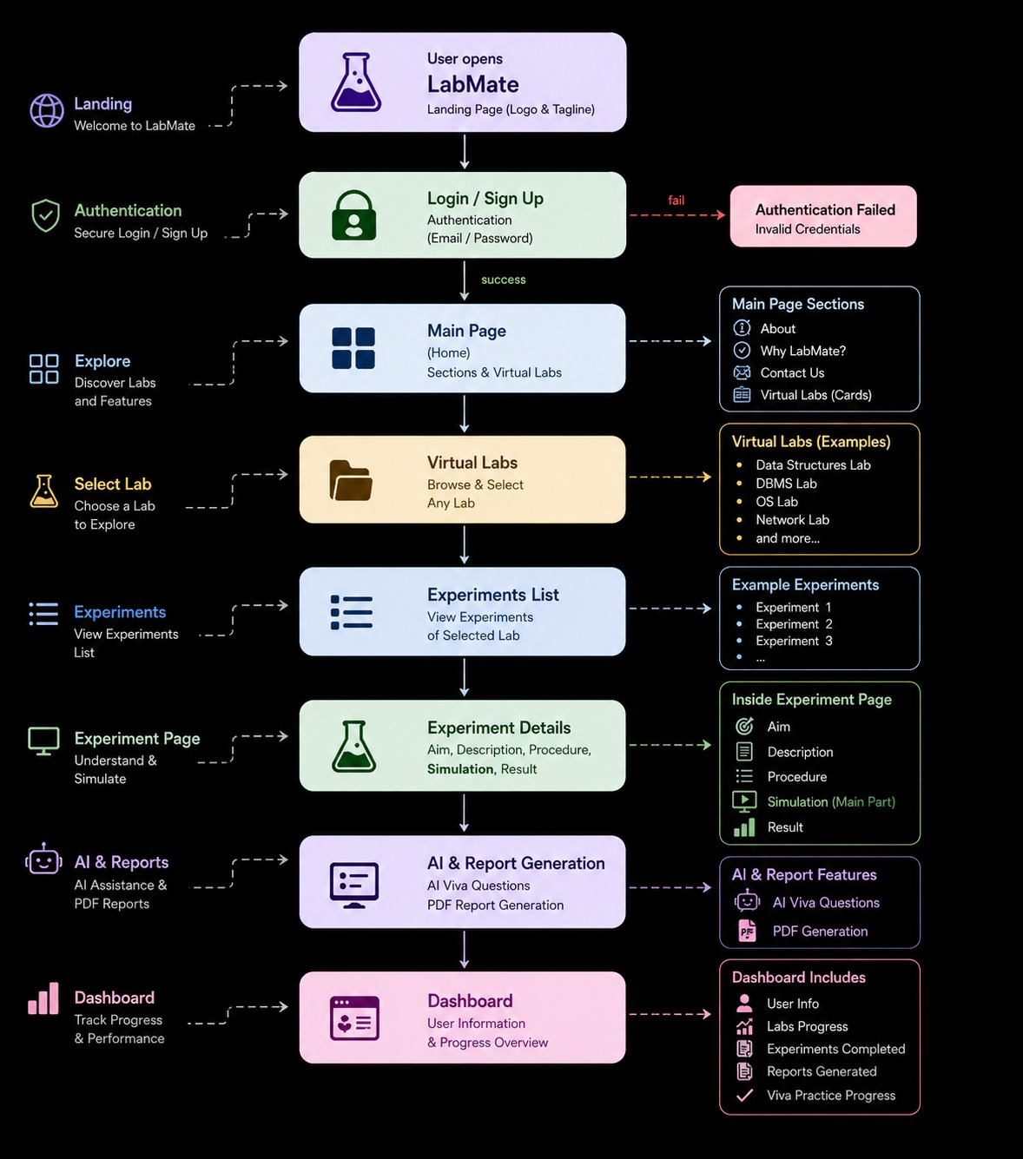
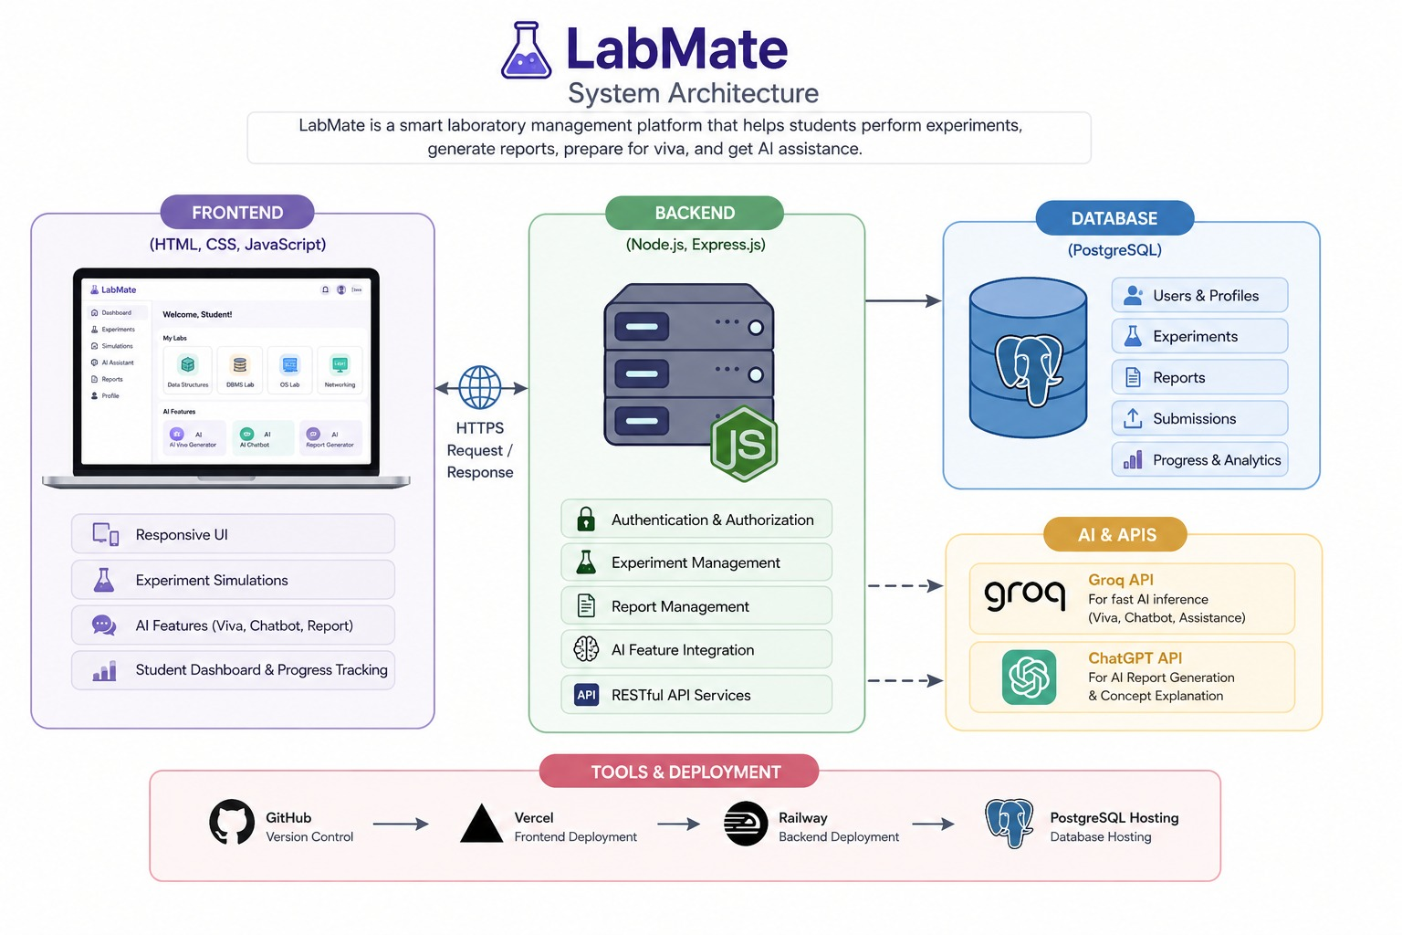

In_Scope:
- Interactive virtual laboratory simulations
- Experiment workflow management
- Observation table handling and editing
- Student dashboard and activity tracking
- Responsive web-based laboratory interface
- User authentication and access management
- Simulation parameter controls and visualization
- Review and analytics dashboard interfaces
- Experiment progress tracking
- Modular backend architecture for scalability
- AI-assisted academic support integration (planned)
- Report generation and export workflows (planned)
- Faculty evaluation and submission systems (planned)
Out_Scope:
- Offline laboratory access
- Real-time multiplayer collaboration
- AR/VR-based laboratory simulations
- Full institutional ERP integration
- Blockchain-based certification systems
- Voice-controlled virtual assistants
- Mobile-native application development
- Advanced enterprise-scale analytics systems
- Fully autonomous AI evaluation systems
- Future_Enhancements
- AI-Based Academic Assistance
- AI-powered viva question generation
- Intelligent chatbot for experiment guidance
- AI-generated experiment summaries
- Personalized learning recommendations
- Report & Documentation Automation
- Automated PDF lab record generation
- Advanced report customization options
- Export reports with charts and analytics
- Smart observation validation systems
- Faculty & Evaluation Systems
- Faculty review and feedback modules
- Experiment evaluation and marking workflows
- Student submission tracking
- Performance-based analytics dashboards
- Simulation Expansion
- Additional engineering laboratory simulations
- Improved graph plotting and real-time calculations
- Multi-domain experiment support
- Enhanced simulation accuracy and interactivity
- Platform Scalability
- Complete PostgreSQL integration
- Advanced backend API architecture
- Cloud deployment optimization
- Improved security and session management
- User Experience Improvements
- Notification and reminder systems
- Experiment bookmarking
- Achievement badges and progress milestones
- Enhanced responsive design and accessibility

- Conclusion
- LabMate AI is an evolving smart laboratory assistance platform focused on improving practical learning experiences for engineering students through interactive simulations, centralized academic workflows, and intelligent digital support systems.
- The project currently establishes a strong foundation with responsive frontend architecture, authentication systems, dashboard interfaces, simulation workflows, and modular backend design. Its primary objective is to simplify laboratory management while making practical learning more accessible, organized, and engaging for students and faculty members.
- The platform is designed with scalability in mind, allowing future integration of AI-powered academic assistance, automated report generation, advanced analytics, and faculty evaluation systems. By combining simulation-driven learning with modern web technologies, LabMate AI aims to become a comprehensive digital ecosystem for academic laboratory education.
- Future development will focus on backend expansion, database integration, intelligent automation, and enhanced user experience to further strengthen the platform’s educational impact and technical capabilities.

